Lab 1

Instructor: Dr. Jie Shen
Release date: Jan. 20, 2021
Due date: Jan. 30, 2021

Student Name: Demetrius Johnson

Task 1
Use ssh or another similar software tool (e.g. putty and WinSCP) to connect login.umd.umich.edu and sign on to your Unix account by using the unique name and password of your UM-D account. See the file at Canvas for the introduction to SSH Secure Shell Client and File Transfer.

Logging in screen (successful):
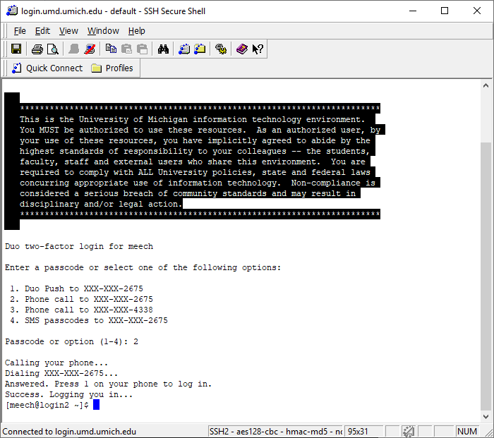

Type date to show the current date and time:
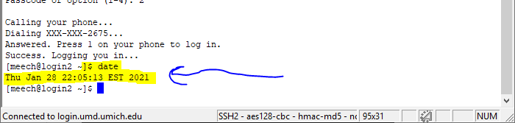

Type pwd to show the current working directory:
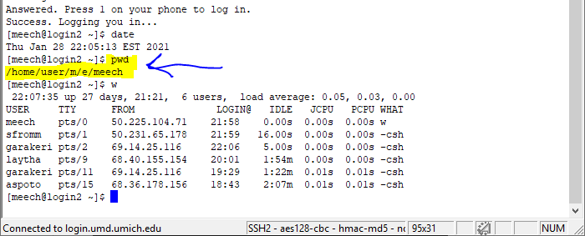

Question 1: What is your home directory ?:

The Home directory is the directory (folder) that contain the personal files of the all user profile home directories (directories) on the system hard drive. When you first login to the system you enter first into the top-level Home directory, and then directly into your username’s home directory which is stored in the top-level Home directory. For example: top-levelHomeDirectory → usernameHomeDirectory.
Shorthand for the home directory of a specific user profile is the ~ symbol; so if a user logs in, they can use the ~ symbol to access their user-profile home directory.

Use w to find out how many users are using the system:
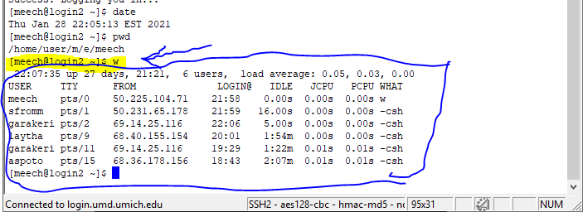

Use man to find out the description of chmod command (I learned I must type q to quit the manual mode):
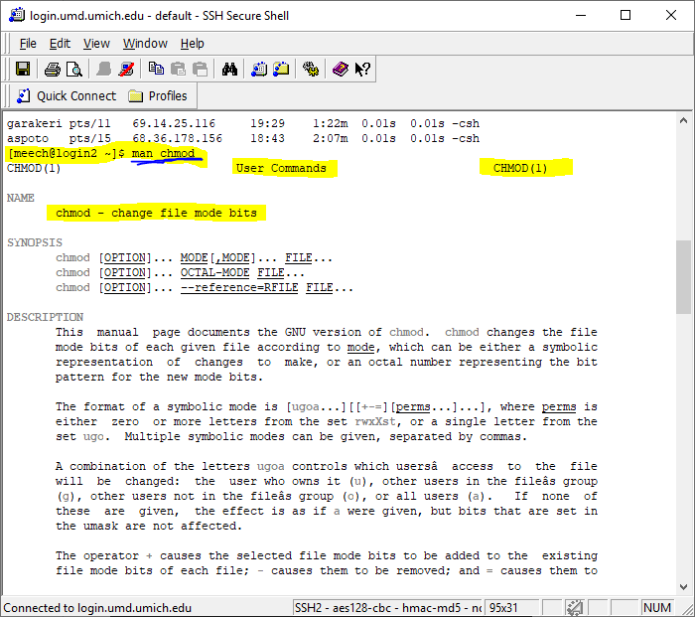

Use ls –al and ls –l to see the contents in the current directory:
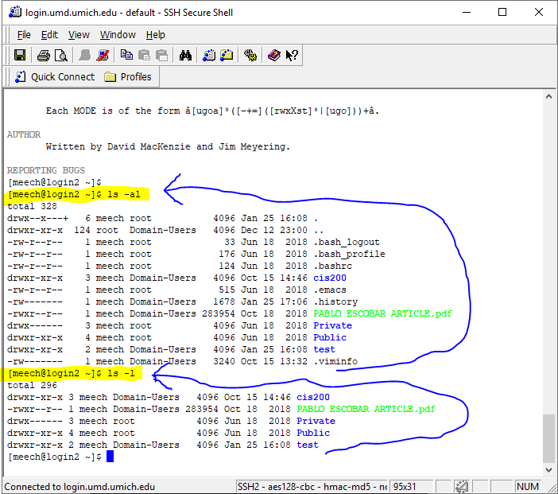

Use mkdir command to create a directory Daughter:
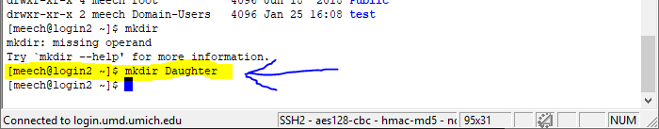

Use cd command to move to this new Daughter directory:
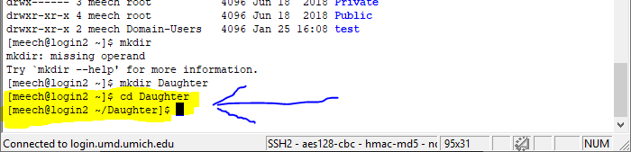

Type pwd to show the current working directory. It should be your home directory/Daughter:
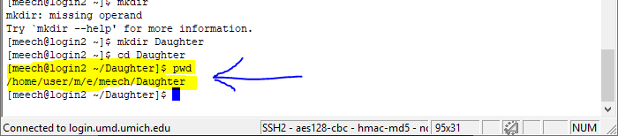

Use mkdir command to create a directory GrandDaughter:
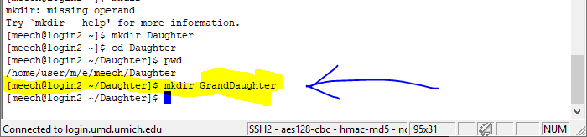

Use cd command to move to this new GrandDaughter directory:
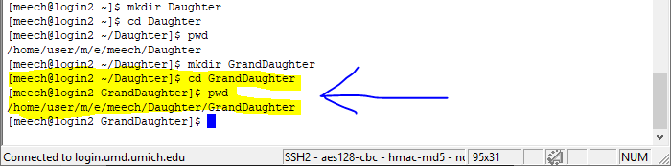

Use ls –al and ls –l to see the contents in this directory. Remember that –a allows you to see the invisible files:
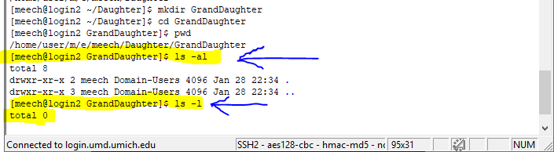

Question 2: What are the invisible files in the directory ?:

The invisible files in a directory are the files which are hidden and the filename starts with a period (.). They are invisible because they are not ordinary files: they are files such as system files which are not accessed or used by the user.

Use cd .. to move to one layer above:
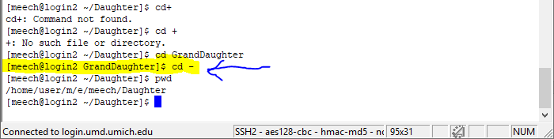

Type pwd to show the current working directory:
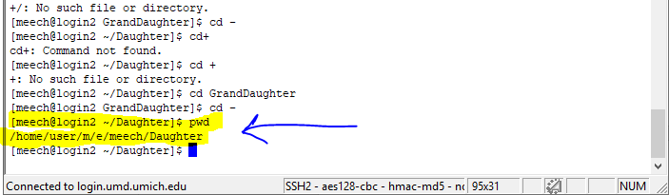

Use cd ~ to move back to the home directory:
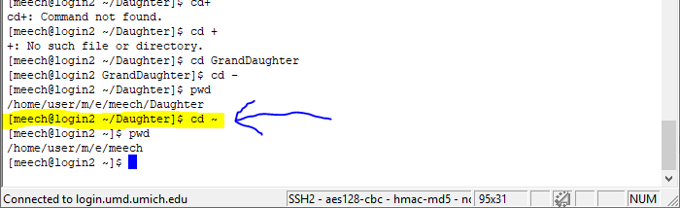

Type pwd to show the current working directory:
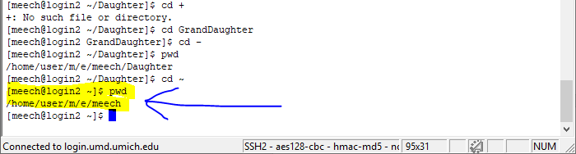

Task 2

Log into Unix Server via SSH File Transfer:
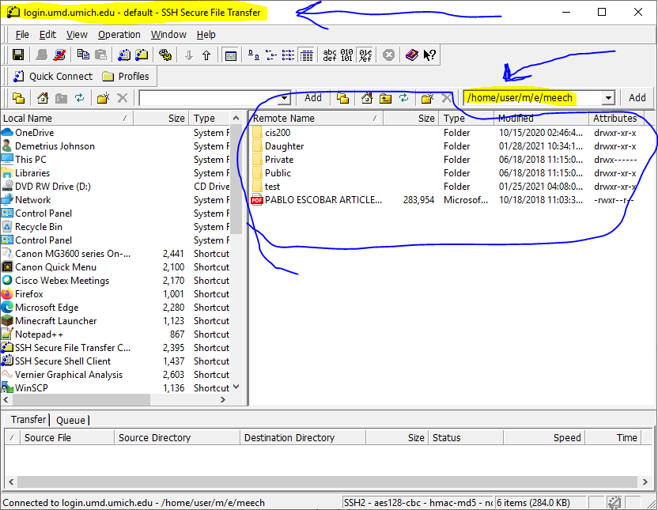

Download the following files from cis200 lab at Canvas:

lab1.cpp

Save these files on your local computer, and use SSH Secure File Transfer or WinScp to make a copy of them to your Unix account under the directory Daughter. If there is no such a directory under your Unix account, you need to create it first before the file transfer:
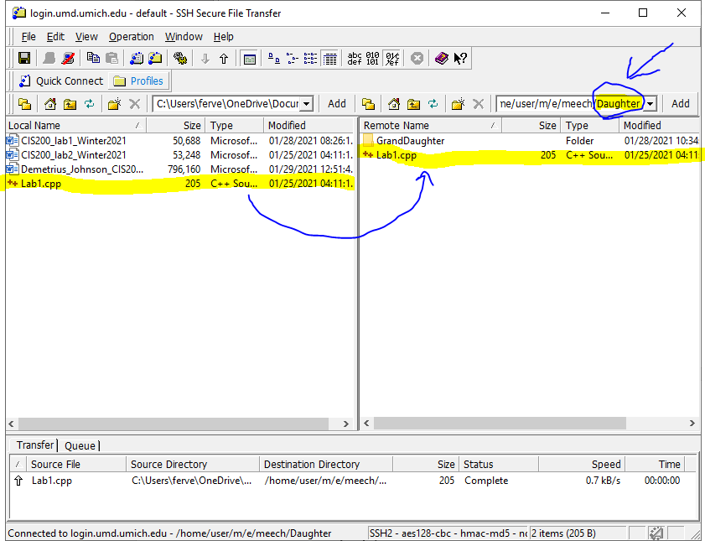

Task 3

Use cd command to move to Daughter directory, and use cat command to check the contents of the .cpp file:
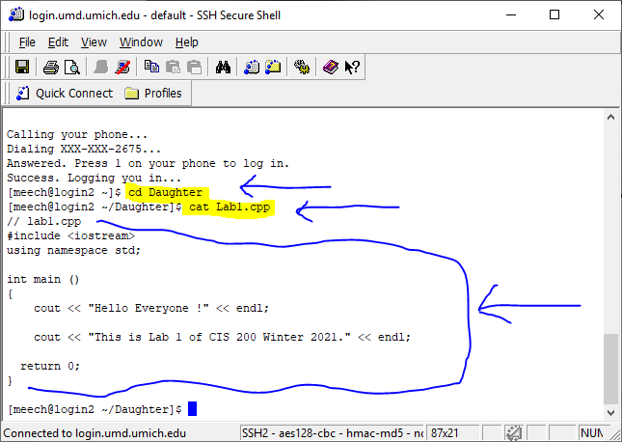

Use ls –al to check all files in the current directory:
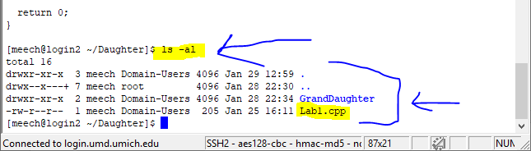

Task 4

vi is the simplest text editor on UNIX systems. To create a file, lab1.cpp, type
vi lab1.cpp
In Daughter directory, use vi (or emacs, pine, or other Unix editors) to edit lab1.cpp, if necessary.

Show use of the vi text editor command:
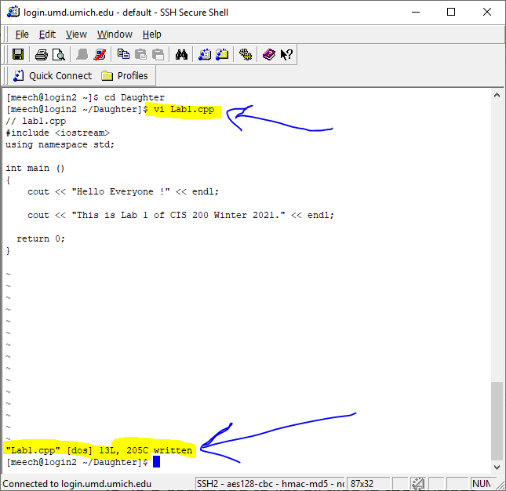

Task 5

Compile lab1.cpp file to make an executable file, myexec, by typing
c++ –o myexec lab1.cpp:
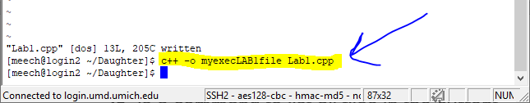

Use ls –al to check all files in the current directory. .o files mean object files generated in the compilation process:
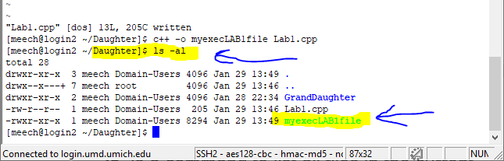

Run your executable myexec and write the screen output below. Note you need to use the current directory as a prefix to run myexec.
Type ./myexec:
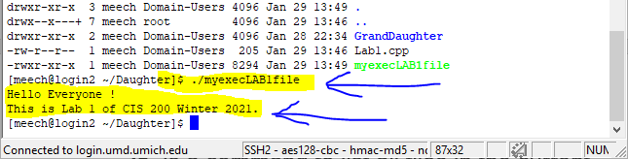

Task 6
Copy the executable name from myexec to myexec2 by using cp command:
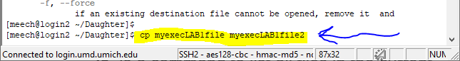

Show that the myexec2 file has been created (note, server kept timing out so I had to keep loggining in:
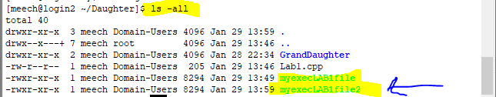

Move the executable name from myexec2 to myexec3 by using mv command:
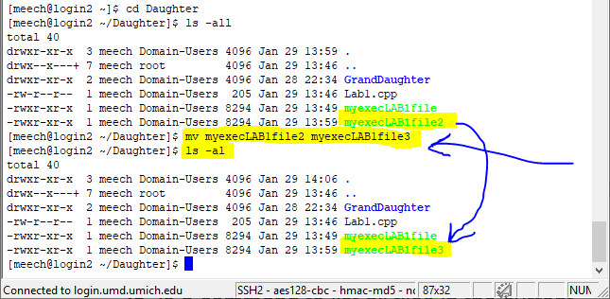

Task 7
Type man echo to show the instruction on echo:
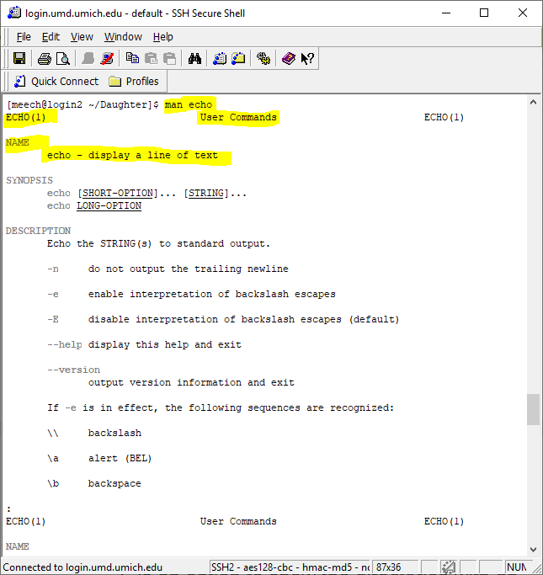

Type man mail to show the definition on command mail:
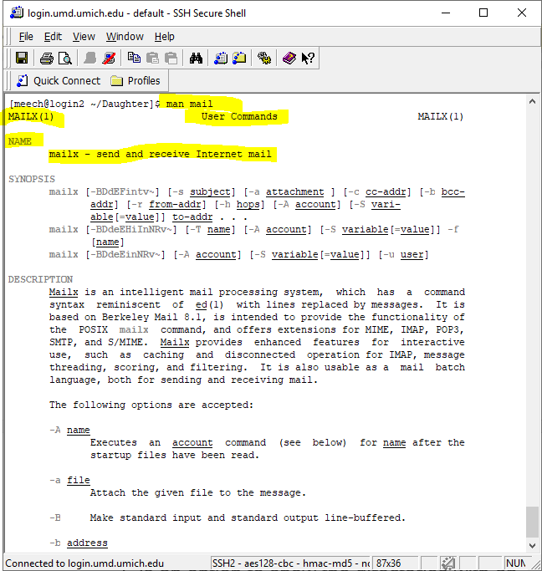

Use mail command to send an email to your UM-D account:
$mail your_name@umich.edu
Subject: Welcome to CIS 200 Winter 2021.
Greeting from Unix by your name: xxx !
Ctrl+D to finish:
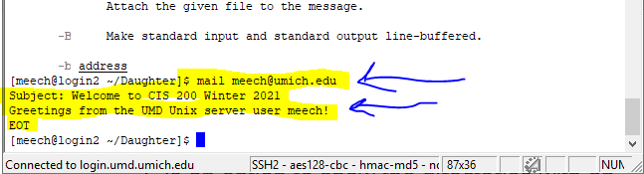

Log into your UM-D email account and check the test email. Create a screenshot as evidence on the email:
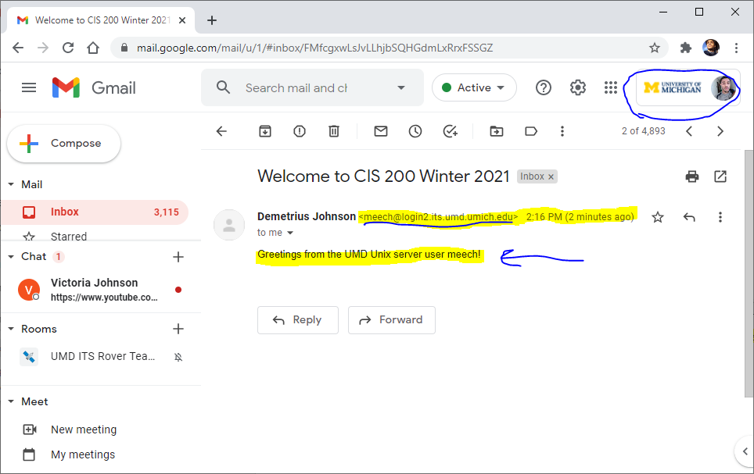

Task 8
Try the following commands:

$ ls –al > listing.txt //redirect output to a file named “listing.txt” (file is created if necessary).
$ more listing.txt //used to view the contents of the listing.txt file:
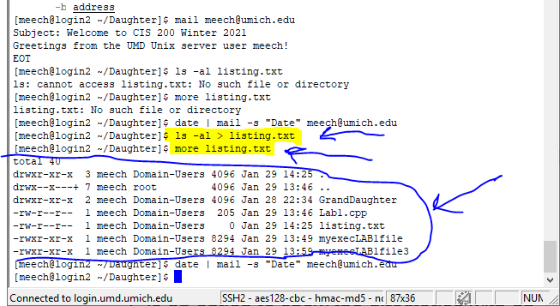

$ date | mail –s “Date” your_name@umich.edu:
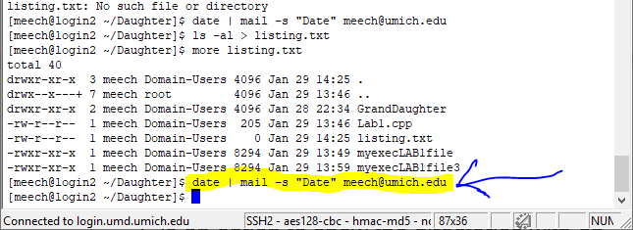

Browse your UM email account to see if you receive the result of running date command. Create a screenshot of the message in your email:

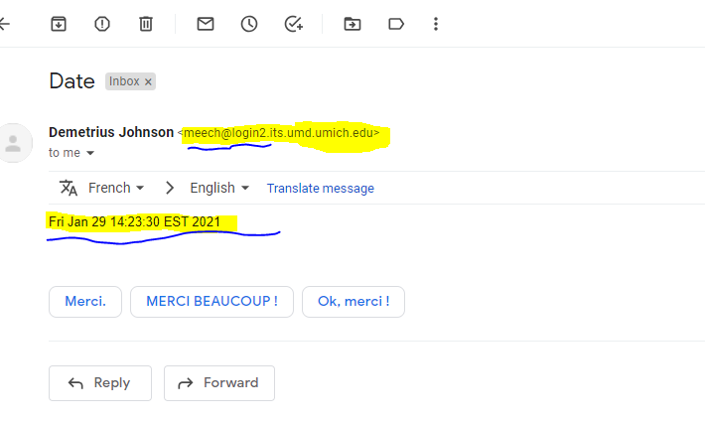

Question 3: What is the redirect in Unix ?

The redirect command sends the out (redirects) of a command to another format such as a text file or another output screen rather than the default terminal window output. It is used by issuing the ‘>’ symbol after issuing a command that will give an output. Similarly, you can also redirect input; input is usually received from the keyboard by default – use the ‘<’ symbol to get input for a command from another source such as a text file.

Question 4: What is the pipe in Unix ?

The Pipe in Unix is the | symbol, and it is used to concatenate one or more commands into one large sequentially executed command. Each consecutive command uses the output of the command that came before it, separated by a pipe, to determine the input for its command. That is why it is called the pipe command and uses the pipe symbol, because the command sequence is funneled down a sequentially dependent “pipeline”.

Note: I did not put as much description (just the title and small description for each screenshot) because instead my description was to use many screenshots and annotate those screenshots which took quite a while.

